Hands-on Lab: Joins

**Estimated time needed:** 25 minutes

In this lab, you will run through some SQL practice problems that will provide hands-on experience with the different kinds of join operations.

**How does a CROSS JOIN (also known as Cartesian Join) statement syntax look?**

**SELECT** column_name(s)

**FROM** table1

**CROSS** **JOIN** table2;

**How does an INNER JOIN statement syntax look?**

**SELECT** column_name(s)

**FROM** table1

**INNER** **JOIN** table2

**ON** table1.column_name = table2.column_name;

**WHERE** condition;

**How does a LEFT OUTER JOIN statement syntax look?**

**SELECT** column_name(s)

**FROM** table1

**LEFT OUTER JOIN** table2

**ON** table1.column_name = table2.column_name

**WHERE** condition;

**How does a RIGHT OUTER JOIN statement syntax look?**

**SELECT** column_name(s)

**FROM** table1

**RIGHT OUTER JOIN** table2

**ON** table1.column_name = table2.column_name

**WHERE** condition;

**How does a FULL OUTER JOIN statement syntax look?**

**SELECT** column_name(s)

**FROM** table1

**FULL** **OUTER** **JOIN** table2

**ON** table1.column_name = table2.column_name

**WHERE** condition;

**How does a SELF JOIN statement syntax look?**

**SELECT** column_name(s)

**FROM** table1 T1, table1 T2

**WHERE** condition;

Software Used in this Lab

In this lab, you will use an [IBM Db2 Database](https://www.ibm.com/products/db2-database). Db2 is a Relational Database Management System (RDBMS) from IBM, designed to store, analyze and retrieve data efficiently.

To complete this lab you will utilize a Db2 database service on IBM Cloud. If you did not already complete this lab task earlier in this module, you will not yet have access to Db2 on IBM Cloud, and you will need to follow the lab below first:

* [Hands-on Lab : Sign up for IBM Cloud, Create Db2 service instance and Get started with the Db2 console](https://cf-courses-data.s3.us.cloud-object-storage.appdomain.cloud/IBMDeveloperSkillsNetwork-DB0201EN-SkillsNetwork/labs/Labs_Coursera_V5/labs/Lab%20-%20Sign%20up%20for%20IBM%20Cloud%20-%20Create%20Db2%20service%20instance%20-%20Get%20started%20with%20the%20Db2%20console/instructional-labs.md.html)

Database Used in this Lab

The database used in this lab is an internal database. You will be working on a sample HR database. This HR database schema consists of 5 tables called **EMPLOYEES**, **JOB_HISTORY**, **JOBS**, **DEPARTMENTS** and **LOCATIONS**. Each table has a few rows of sample data. The following diagram shows the tables for the HR database:

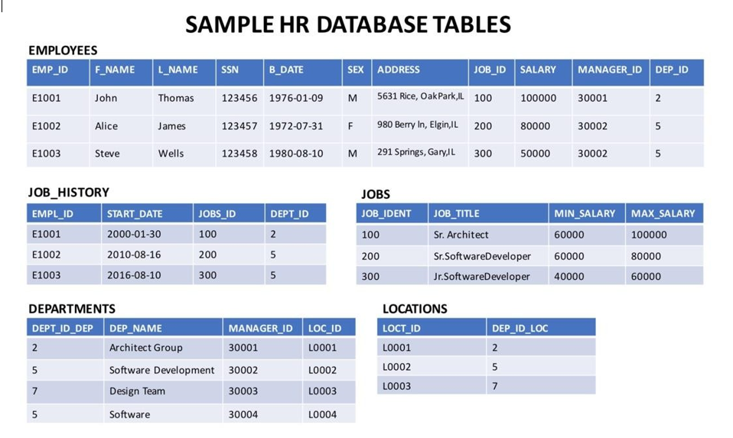

**NOTE:** This lab requires you to have all 5 of these tables of the HR database populated with sample data on Db2. If you didn't complete the earlier lab in this module, you won't have the tables above populated with sample data on Db2, so you will need to go through the lab below first:

* [Hands-on Lab : Create tables using SQL scripts and Load data into tables](https://cf-courses-data.s3.us.cloud-object-storage.appdomain.cloud/IBMDeveloperSkillsNetwork-DB0201EN-SkillsNetwork/labs/Labs_Coursera_V5/labs/Lab%20-%20Create%20tables%20using%20SQL%20scripts%20and%20Load%20data%20into%20tables/instructional-labs.md.html)

Objectives

After completing this lab you will be able to:

* Perform different kinds of join operations

Instructions

When you approach the exercises in this lab, follow the instructions to run the queries on Db2:

* Go to the [Resource List](https://cloud.ibm.com/resources?utm_medium=Email&utm_source=Nurture&utm_content=000026UJ&utm_term=10006555&utm_id=SkillsNetwork-Courses-IBMDeveloperSkillsNetwork-DB0201EN-SkillsNetwork-20127838) of IBM Cloud by logging in where you can find the Db2 service instance that you created in a previous lab under **Services** section. Click on the **Db2-xx service**. Next, open the Db2 Console by clicking on **Open Console** button. Click on the 3-bar menu icon in the top left corner and go to the **Run SQL** page. The Run SQL tool enables you to run SQL statements.
  + If needed, follow [Hands-on Lab : Sign up for IBM Cloud, Create Db2 service instance and Get started with the Db2 console](https://cf-courses-data.s3.us.cloud-object-storage.appdomain.cloud/IBMDeveloperSkillsNetwork-DB0201EN-SkillsNetwork/labs/Labs_Coursera_V5/labs/Lab%20-%20Sign%20up%20for%20IBM%20Cloud%20-%20Create%20Db2%20service%20instance%20-%20Get%20started%20with%20the%20Db2%20console/instructional-labs.md.html)

Exercise

1. Problem:

*Select the names and job start dates of all employees who work for the department number 5.*

HintSolutionOutput

1. Problem:

*Select the names, job start dates, and job titles of all employees who work for the department number 5.*

HintSolutionOutput

1. Problem:

*Perform a Left Outer Join on the EMPLOYEES and DEPARTMENT tables and select employee id, last name, department id and department name for all employees.*

HintSolutionOutput

1. Problem:

*Re-write the previous query but limit the result set to include only the rows for employees born before 1980.*

HintSolutionOutput

1. Problem:

*Re-write the previous query but have the result set include all the employees but department names for only the employees who were born before 1980.*

HintSolutionOutput

1. Problem:

*Perform a Full Join on the EMPLOYEES and DEPARTMENT tables and select the First name, Last name and Department name of all employees.*

HintSolutionOutput

1. Problem:

*Re-write the previous query but have the result set include all employee names but department id and department names only for male employees.*

HintSolutionOutput